KAJAL: A DEVOTED COMMUNITY VOLUNTEER
“Volunteers do not necessarily have the time; they just have the heart.”
~Elizabeth Andrew
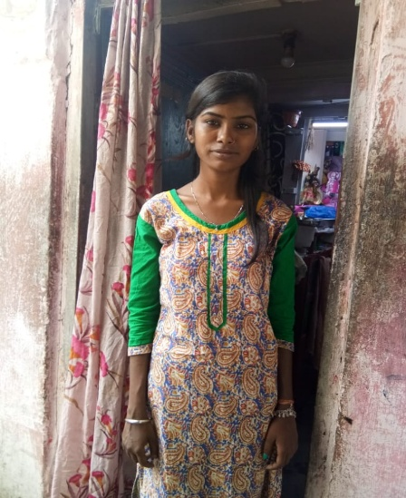
According to ‘Right to Education Act, 20009’ the government has mandated to enroll children as per their current age and the schools are also doing the same. But, children who live in slums and squatter colonies of city like Kolkata neither have the basic education nor have the capacity to cope up with present academic standards. In this situation, DRCSC and Save the Children started a project on “Ensuring Quality Education” in 2017 in 25 urban schools and surrounding areas keeping in mind about those lagging behind children. To be more effective and constructive the facilitators identified some entrusted community volunteers from the local areas. Here is a living example of that type of dedicated person who has done her job excellently.

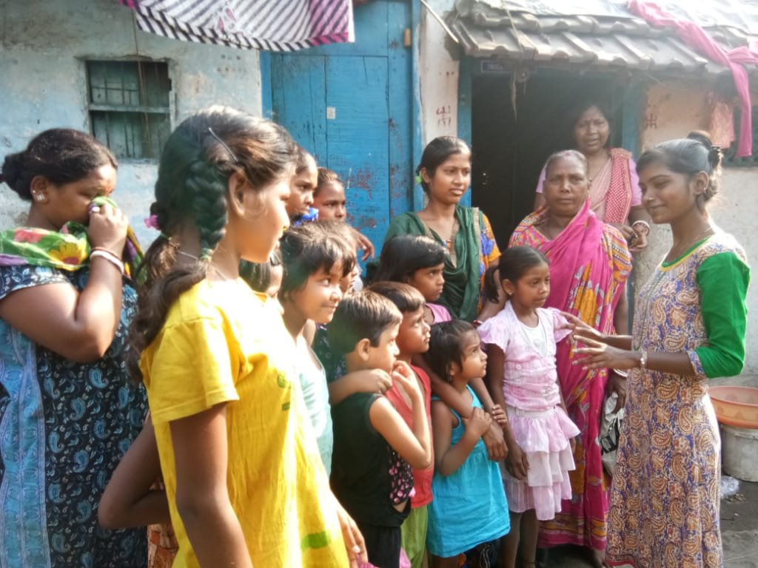
Bastuhara Vidyapith is one of the oldest school in Kulia Tangra locality and one school among the 25 schools under this project. Kajal Ghosh started working with DRCSC as a community volunteer from August, 2017. Living in her maternal house Kajal has a tremendous wish to work for the betterment of the children. As she studied in Baastuhara School till fifth standard, has a deep nostalgia with this school. But today’s Kajal has to face so many hurdles till date from the beginning.
Kajal lives in 6/1, Mathur Babu Lane, Kolkata-700 015. Being a single child she never got the privilege of affection, caring and love from her parents that she deserved. Right from her early childhood, she was exposed to domestic violence in her family. As her father had no actual place for living and he was a regular heavy drunker so they had to live in the maternal house with some pity approach of others. Her father’s name is Sri Tapan Ghosh, who is a daily labour in a plastic company. Her mother is Srimati Chandana Ghosh, who is a domestic help.
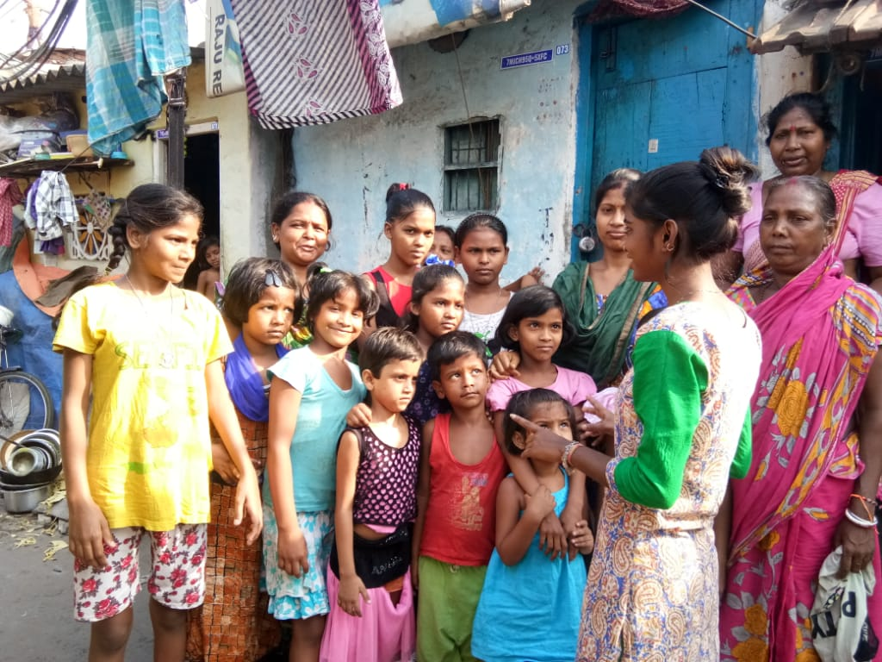
After completion of fifth standard from Baastuhara, Kajal joined Shanti Sangha School for Girls for upper primary education. While studying in upper primary she found there were so many struggling peers like her. She tried herself, taking support from some large- hearted teachers to complete her Madhyamik Examination but she could not cleared it. She wished to appear it another time in the following year of 2016 but destiny had say something else to say. All through her life her cherished dream remained unfulfilled. Then she determined to try her level best for the retention of other children in her locality. After being dropped out of school she started to work as a daily labour of leather strip cutting. Now she earns more or less Rs 700/- per month.
When she was fourteen years old, she and other peers of her age formed a group. They organized a ‘sit and draw’ competition with local children after saving their refreshment money. They collected mattresses from house to house to organize that event. Crayons, pencils and tiffin boxes were given away to the participants as a token of appreciation.
“I would extend my cooperation and help to everyone who wish to work for the betterment of our locality”.
~ Kajal

In 2017, DRCSC’s facilitator met her when she was trying to find out a way for working with the under privileged children. Both of them worked with other volunteers hand to hand for enrolment as well as retention of every children in school.
Kajal organized and facilitated meetings and FGDs with community people on the issues of basic health and hygiene, education, proper sanitation, school readiness etc. She also teaches the children regularly in ‘Mobile Learning Centre’. Her participation in ‘Community Volunteers Meet’ is worth mention. Others also drew inspiration from her exemplary role towards the community. With a few young peers of her age, Kajal endeavored to form a group namely “Amra Sabai”. All the members of the group share a commonality that they all are aspirant of vocational training.

